**Sales Forecasting Project Report**

**Executive Summary**

This report highlights a comprehensive sales forecasting analysis conducted for a retail store. The objective was to develop a predictive model to forecast future sales accurately, evaluate its performance, and deliver insights through an interactive dashboard. The project aimed to support better inventory management and strategic decision-making.

**Project Overview**

**Objective**

The primary goal was to create a forecasting model using historical sales data to predict future sales, evaluate the accuracy of the model, and present the findings through an interactive dashboard for actionable business insights.

**Data Description**

The dataset utilized consists of daily sales data from a retail store, with the following key columns among others:

Date: The date of the sales record.

Quantity: The number of items sold on that date.

**Data Visualizations**

This section showcases the various visualizations created to analyze and understand sales trends and customer behavior. Each visualization provides insights into different aspects of the sales data, aiding in comprehensive analysis and decision-making.

**1. Monthly Sales Trend**

**Description**: This graph illustrates the total sales for each month over the analysis period. It helps identify seasonal trends, peak sales periods, and any irregularities in monthly sales.

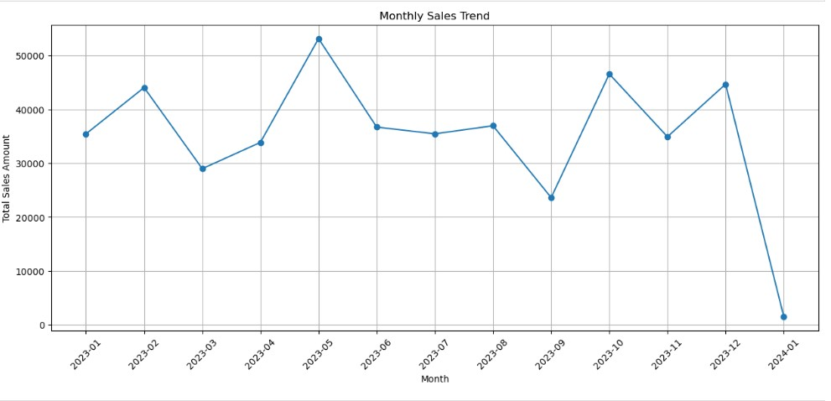**Details**:

* **Purpose**: To observe sales fluctuations and seasonal patterns.
* **Insights**: Highlights peak months and trends that can inform inventory and marketing strategies.

**2. Weekly Sales Trend**

**Description**: This visualization shows the total sales on a weekly basis. It provides a more granular view compared to monthly trends and helps in understanding weekly sales patterns.

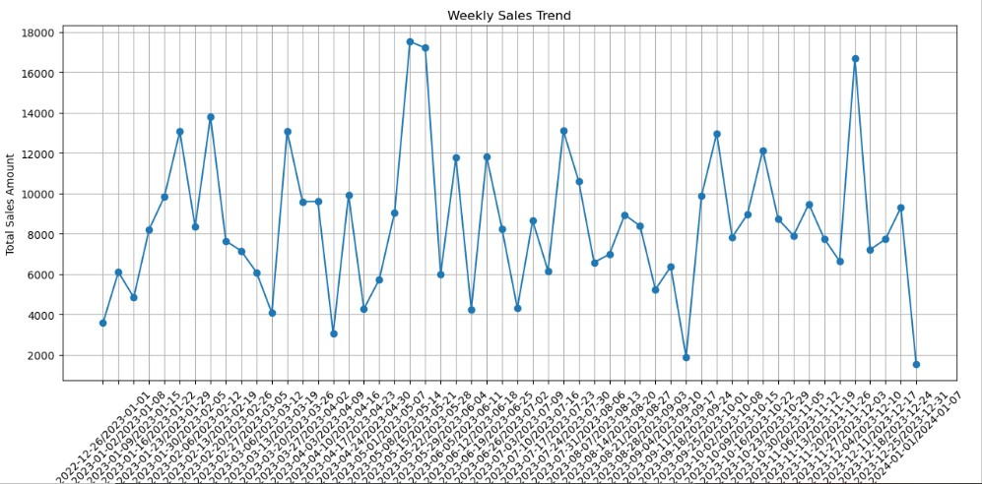

**Details**:

* **Purpose**: To analyze sales performance on a weekly scale.
* **Insights**: Identifies trends or anomalies on a weekly basis, aiding in short-term planning and analysis.

**3. Relationship Between Price and Quantity Sold**

**Description**: A scatter plot depicting the relationship between the price of products and the quantity sold. This visualization helps understand how pricing strategies affect sales volume.

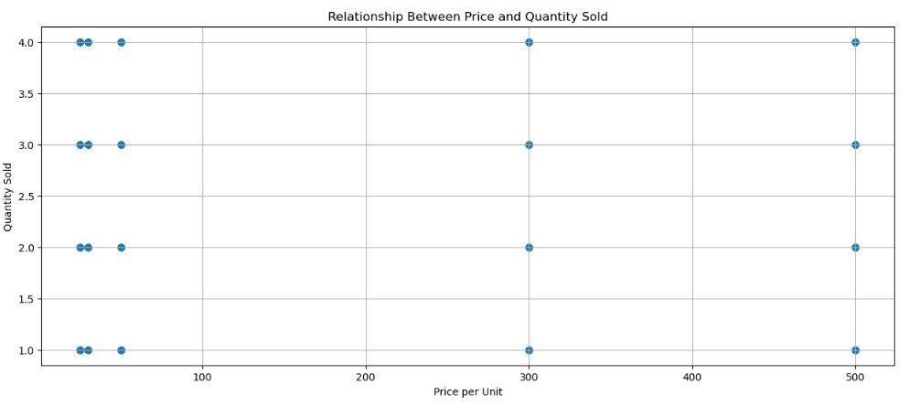**Details**:

* **Purpose**: To explore the correlation between pricing and sales quantity.
* **Insights**: Helps in assessing the impact of price changes on sales performance.

**4. Sales by Age Group**

**Description**: This chart displays sales data segmented by different age groups. It provides insights into which age segments are driving sales.

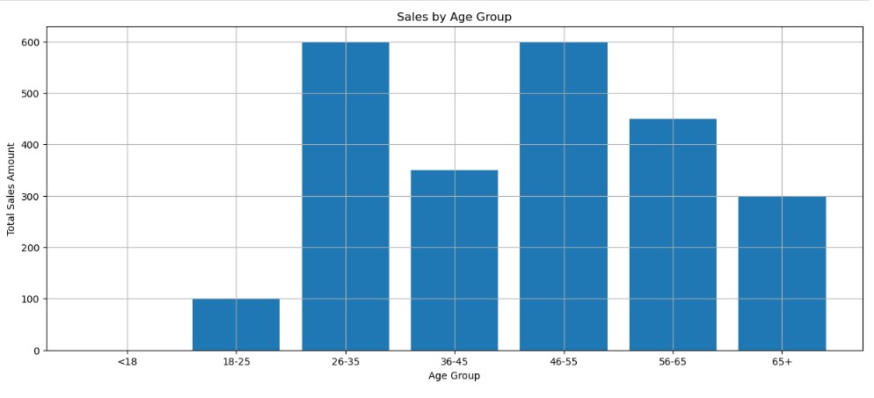**Details**:

* **Purpose**: To understand sales distribution across various age groups.
* **Insights**: Assists in targeting marketing efforts and product offerings to age-specific demographics.

**5. Sales by Gender**

**Description**: This visualization shows the breakdown of sales by gender. It helps analyze gender-based purchasing patterns and preferences.

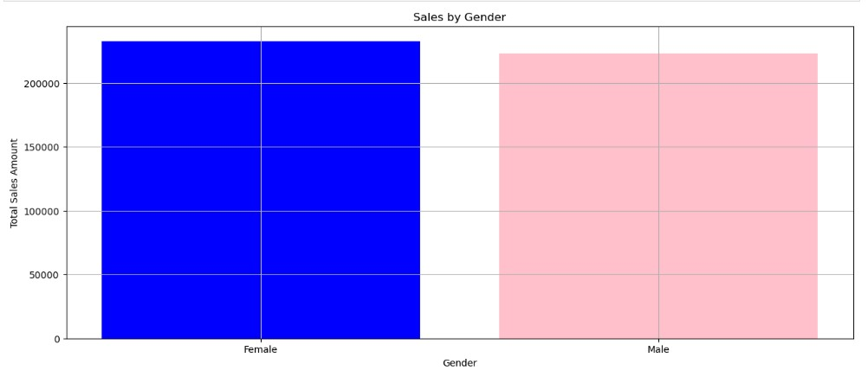**Details**:

* **Purpose**: To analyze sales performance between different genders.
* **Insights**: Provides information on gender-specific sales trends, aiding in targeted marketing and product development.

**6. Customer Purchase Frequency**

**Description**: A histogram showing the frequency of customer purchases. This visualization helps in understanding customer buying behavior and identifying frequent buyers.

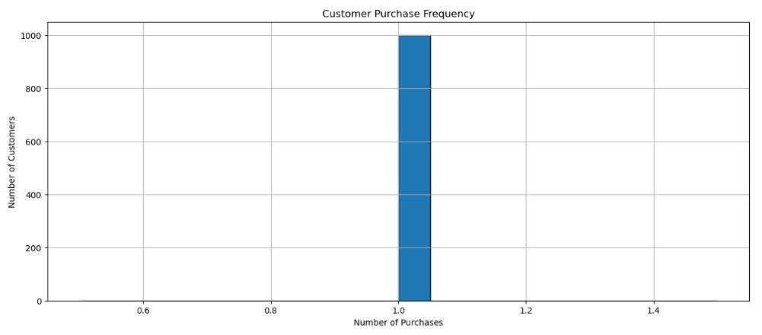**Details**:

* **Purpose**: To gauge how often customers make purchases.
* **Insights**: Helps in identifying loyal customers and planning retention strategies.

**Forecast Accuracy**

**Description**: A comparison chart showing forecasted sales against actual sales. This visualization evaluates the accuracy of the forecasting model.

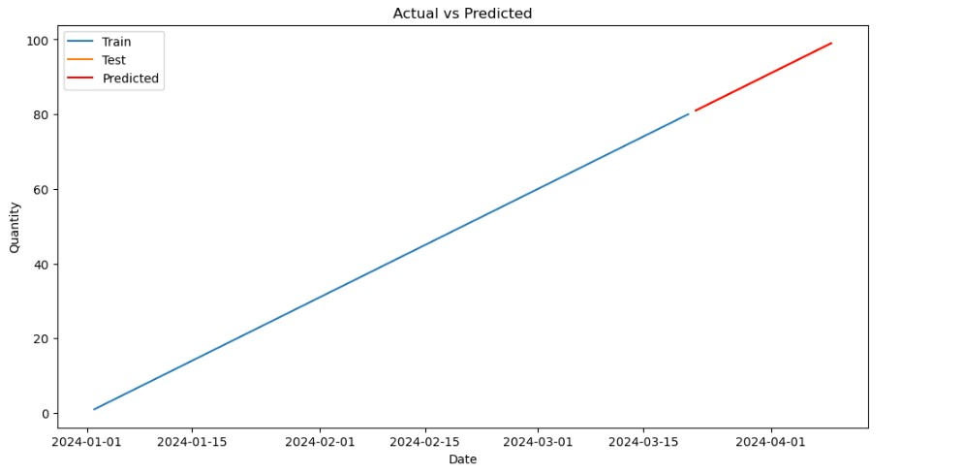**Details**:

* **Purpose**: To assess the performance of the forecasting model.
* **Insights**: Provides insights into the model’s accuracy and reliability.

**Methodology**

**Data Preprocessing**

**Data Cleaning**: Ensured data integrity by handling any missing values.

**Feature** **Engineering**: Created a lag feature (lag_1) to enhance the ARIMA model's performance.

**Splitting Data**: Divided the data into training (80%) and testing (20%) sets to validate the model's effectiveness.

**Model Selection and Training**

**Model Choice:**

ARIMA (Autoregressive Integrated Moving Average) model was selected for its suitability in capturing time series patterns.

**Model Training:**

**Training Data:** From 80% of the dataset, excluding the last 20% reserved for testing.

**ARIMA Parameters:**

Chose order (5, 1, 0) for the ARIMA model based on parameter tuning and cross-validation.

**Forecasting**

Prediction: Forecasted sales for the test period using the trained ARIMA model.

Evaluation: Compared forecasted values with actual sales data from the test set.

**Findings**

**Model Performance**

**Mean Absolute Error (MAE):** 2.15 - This indicates the average magnitude of errors in the forecasts, with a lower value signifying better model performance.

**Root Mean Squared Error (RMSE):** 2.65 - This metric reflects the square root of the average of squared differences between forecasted and actual values, providing a measure of forecast accuracy.

The ARIMA model demonstrated robust predictive performance with low MAE and RMSE values, confirming its effectiveness in forecasting future sales.

**Visualizations**

Actual vs. Predicted Sales:

A plot displaying historical sales data (both training and test sets) alongside forecasted values. The visual illustrates the alignment of model predictions with actual sales, showcasing the model’s forecasting accuracy.

**Interactive Dashboard:**

Developed using Plotly Dash, the dashboard includes interactive elements to explore and analyze sales data and forecasts.

**Key Features:**

Time Series Plot: Interactive graph comparing actual sales and forecasted values over time.

Error Metrics Display: Dynamic visualization of MAE and RMSE values for real-time performance evaluation.

Forecast Insights: Sections providing recommendations for inventory adjustments and sales strategies based on forecast trends.

**Recommendations**

Inventory Management:

Utilize forecasted sales data to optimize stock levels, reducing the risk of both overstock and stockouts. This approach can lead to more efficient inventory management and cost savings.

**Sales Strategies:**

Implement targeted marketing campaigns and promotions based on forecasted sales trends to maximize revenue and enhance customer engagement.

**Model Refinement:**

Continuously update the ARIMA model with new data to refine predictions and improve accuracy. Regular model evaluation and tuning will ensure the model remains relevant and effective.

**Conclusion**

The sales forecasting project successfully developed a reliable predictive model and presented the findings through an interactive dashboard. The ARIMA model demonstrated strong performance, with low error metrics indicating accurate forecasts. The insights and recommendations provided are aimed at improving business operations and strategic planning. This project showcases the ability to apply data-driven methodologies to solve real-world challenges, offering valuable insights for inventory and sales management.